### Dimensions valves DMV/12 (mm)

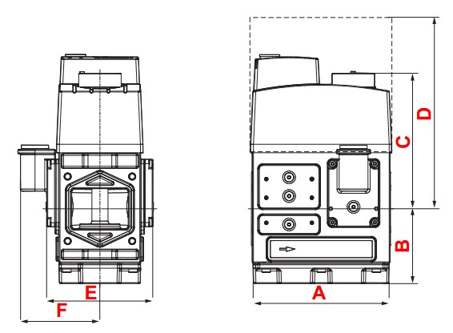

|  |  |  |  |  |  |  |  |
| --- | --- | --- | --- | --- | --- | --- | --- |
| **Valve type** | **A** | **B** | **C** | **D** | **E** | **F** | **Weight (kg)** |
| Double solenoid valve DMV 525/12 | 162 | 88 | 179 | 275 | 125 | 97 | 7.0 |